| **Test Name** | | | User Can Open A Single Sensor Window | | | |
| --- | --- | --- | --- | --- | --- | --- |
| **Use Case Tested:** | | | View A Single Water Quality Metric On A Single Sensor | | | |
| **Test Description:** | | | The “Sensor” menu option is clicked, followed by selecting a sensor and the window with all salinity levels is displayed. | | | |
| **Pre-conditions** | | | Must Not Be On A single Sensor Screen | | | |
| **Post-conditions** | | | The currently displayed window should be that of a single sensor window | | | |
| **Notes:** | | **Unsure how else to demonstrate a button click other than through screenshots.** | | | | |
| **Result (Pass/Fail/Warning/Incomplete)** | | **Pass** | | | | |
|  | **TEST STEP** | | | **EXPECTED TEST RESULTS** | P | F |
|  | Click On Sensors On Menu | | | Sensors Window Is Displayed | X |  |
|  | Click On A Sensor In A List | | | All Single Sensor Window Is Displayed | X |  |
|  |  | | |  |  |  |

**Test Output Screenshots**

Start

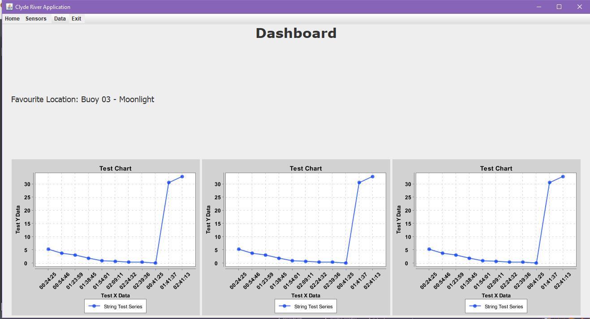

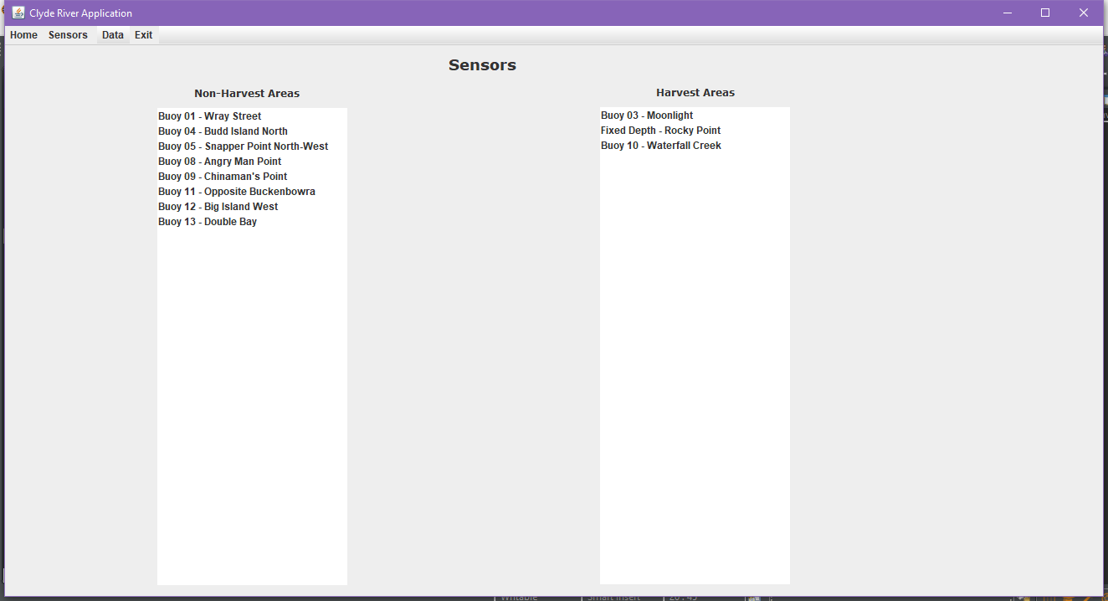

Result

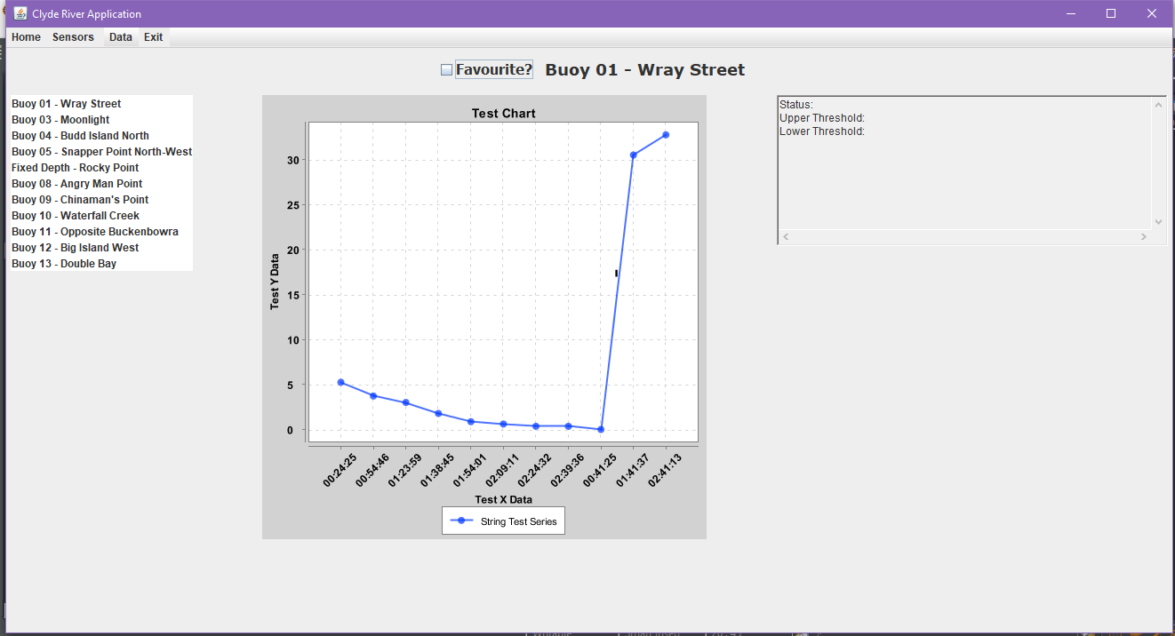

File I/O

